2026 AHVAP ANNUAL CONFERENCE AND INDUSTRY PARTNER EXPO

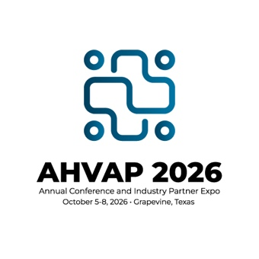

CONFERENCE ATTENDANCE JUSTIFICATION LETTER TEMPLATE
Customize the bracketed fields with your personal information before submitting to your supervisor.
[Date]
[Supervisor's Name]
[Title]
[Organization/Facility Name]
[Address]
[City, State, ZIP]
Dear [Supervisor's Name],
I am writing to request approval and financial support to attend the 2026 AHVAP Annual Conference and Industry Partner Expo, hosted by the Association for Healthcare Value Analysis Professionals (AHVAP). The conference is scheduled for October 5-8, 2026 in Grapevine, Texas. This premier educational event is the foremost gathering of healthcare value analysis professionals in the nation, and I strongly believe that my attendance will deliver measurable benefits to our organization.

About AHVAP and the Annual Conference
AHVAP (the Association for Healthcare Value Analysis Professionals) is the leading professional organization dedicated to healthcare value analysis, supply chain optimization, and clinical resource management. The Annual Conference brings together hundreds of healthcare professionals, clinical experts, and industry leaders to share best practices, emerging research, and innovative strategies that drive cost savings and improve patient outcomes.

Key Learning Objectives & Professional Development
By attending the 2026 AHVAP Annual Conference and Industry Partner Expo, I expect to gain knowledge and skills in the following areas:
- Evidence-based value analysis methodologies and frameworks applicable to our organization's supply chain and procurement processes
- Strategies for reducing clinical variation and standardizing products to achieve cost savings without compromising patient care quality
- Regulatory and compliance updates affecting healthcare supply chain and value analysis committees
- Access to a new Implementation toolkit for Instructions for Use for medical products and devices
- Networking with peer professionals to benchmark our practices and identify opportunities for improvement
- Emerging technologies and innovations in healthcare supply chain management
- [Add additional topic relevant to your role and organizational goals]

Organizational Benefits & Return on Investment
The knowledge and connections gained at this conference will directly benefit [Organization Name] in several meaningful ways:
- Cost Savings Identification: I will return with actionable strategies for product standardization and value analysis committee process improvements that can contribute to measurable supply cost reductions.
- Staff Education and Competency Maintenance: I will share key takeaways with colleagues and leadership through a post-conference debrief, extending the value of this investment across our team. AHVAP is providing me with a structured debrief toolkit to bring back best practices from the conference directly to our organization.
- Benchmarking & Best Practices: Direct access to peer professionals will allow me to benchmark our current processes against national standards and identify gaps.
- Regulatory Preparedness: Up-to-date compliance and regulatory information will ensure our value analysis program remains current with industry requirements.
- [Customize with a benefit specific to your organization's current initiatives or challenges]

Estimated Attendance Costs
Below is a summary of the estimated costs associated with attending the 2026 AHVAP Annual Conference and Industry Partner Expo:
Expense | Estimated Cost
Conference Registration Fee | [$ Amount]
Travel (Airfare/Mileage) | [$ Amount]
Hotel Accommodations ([#] nights) | [$ Amount]
Meals & Per Diem | [$ Amount]
Ground Transportation | [$ Amount]
Miscellaneous/Other | [$ Amount]
TOTAL ESTIMATED COST | [$ Total Amount]

I am confident that the investment in this conference will yield significant tangible returns for [Organization Name] through improved processes, cost savings opportunities, and enhanced professional expertise. I am committed to sharing everything I learn with our team and applying new strategies to advance our value analysis program.
I would welcome the opportunity to discuss this request further at your convenience. Thank you for your consideration and continued investment in my professional development.
Sincerely,
[Your Full Name]
[Your Title]
[Department]
[Organization/Facility Name]
[Phone Number]
[Email Address]

For more information about the 2026 AHVAP Annual Conference, visit: www.ahvap.org

