CONTENTS

CERTIFICATION FOR VALUE ANALYSIS HEALTHCARE PROFESSIONALS......................................................... 3

CERTIFICATION ELIGIBILITY REQUIREMENTS........................................................................................................ 4

PREPARING FOR THE EXAMINATION..................................................................................................................... 4

CERTIFICATION EXAMINATION CONTENT OUTLINE .......................................................................................... 5

TESTING AGENCY........................................................................................................................................................ 9

NONDISCRIMINATION POLICY ................................................................................................................................ 9

COMPLETING YOUR APPLICATION ......................................................................................................................... 9

REGISTERING FOR AN EXAMINATION ................................................................................................................. 11

APPLICATION AND TESTING FEES ........................................................................................................................ 19

APPEALS...................................................................................................................................................................... 19

EXAMINATION ADMINISTRATION........................................................................................................................ 19

TEST CENTER LOCATIONS.................................................................................................................................................... 19
SPECIAL ARRANGEMENTS FOR CANDIDATES WITH DISABILITIES.............................................................................. 20
RESCHEDULING AN EXAMINATION ................................................................................................................................... 20
MISSED APPOINTMENTS AND FORFEITURES .................................................................................................................. 21
INCLEMENT WEATHER, POWER FAILURE OR EMERGENCY........................................................................................... 21

TAKING THE EXAMINATION .................................................................................................................................. 21

IDENTIFICATION..................................................................................................................................................................... 22
SECURITY ................................................................................................................................................................................. 22
PERSONAL BELONGINGS...................................................................................................................................................... 23
EXAMINATION RESTRICTIONS ............................................................................................................................................ 23
MISCONDUCT ......................................................................................................................................................................... 24
COPYRIGHTED EXAMINATION QUESTIONS ..................................................................................................................... 24
COMPUTER LOGIN................................................................................................................................................................. 24
PRACTICE EXAMINATION..................................................................................................................................................... 24
TIMED EXAMINATION .......................................................................................................................................................... 25
CANDIDATE COMMENTS ..................................................................................................................................................... 25

FOLLOWING THE EXAMINATION .......................................................................................................................... 25

HOW SCORES ARE DETERMINED ....................................................................................................................................... 26
SCORE CANCELLATION ......................................................................................................................................................... 26
FAILING TO REPORT FOR AN EXAMINATION.................................................................................................................. 26
CONFIDENTIALITY.................................................................................................................................................................. 26
DUPLICATE SCORE REPORT ................................................................................................................................................. ..27
CERTIFICATION RENEWAL ................................................................................................................................................... 27
EDUCATIONAL CREDITS GUIDE…………………………………………………………………………………………….29
REINSTATEMENT OF EXPIRED CERTIFICATION………………………………………………………………………………………...30

CERTIFICATION FOR VALUE ANALYSIS HEALTHCARE PROFESSIONALS

The Association of Healthcare Value Analysis Professionals (AHVAP) contracted with Owens & Minor
University (OMU) to establish the industry’s first and only healthcare value analysis credential – Certified
Value Analysis Healthcare Professional (CVAHP). CVAHP was created to meet a growing need in the healthcare industry: the skill to apply healthcare value analysis principles to deliver outcome-driven, patient-centered
care at the lowest cost.

AHVAP is nationally recognized as the preeminent authority in providing education, resources and networking to promote value analysis in the healthcare community. When effectively applied, healthcare value analysis delivers value for both organizations and suppliers by supporting collaboration between suppliers, supply chain leaders, physicians, clinicians and other subject matter experts to make evidence-based decisions that result in optimal patient outcomes at the optimal economic value. AHVAP’s mission is to provide information
and promote practices required to evaluate healthcare processes, products and services for clinical quality and cost effectiveness. Log on to www.ahvap.org to learn more about online Healthcare Value Analysis
educational modules and certification.

CERTIFICATION ELIGIBILITY REQUIREMENTS
To sit for the CVAHP examination, you must meet the following requirements:

EDUCATION AND EXPERIENCE
• 2 years formal post-secondary education or higher AND
• 3 years of cumulative experience participating in the VA process**

**Cumulative experience is defined as the total length of time employed with responsibility for value analysis activities. The experience does not have to be consecutive or with a single employer.

Documentation to be submitted to Prometric with the certification registration will include:

• Submission of a letter of reference from the applicant’s manager/director/supervisor verifying that the candidate performs the job functions of a value analysis professional and meets the requirements to sit for certification, or
• Submission of a copy of their job description that specifies responsibility for the job functions of a value analysis professional and confirmation from their human resources department of their tenure in this role (may be documentation from more than one organization in the event there was a change of employers).

PREPARING FOR THE EXAMINATION

We have included a detailed content outline below of the topics and skills included in the exam. Try to be objective about your individual learning needs when deciding how best to study. Plan your study schedule well in advance.
Be sure to answer each question, even the ones for which you are uncertain. Avoid leaving any questions unanswered as this will maximize your chances of passing. It is better to guess than to leave a question unanswered. There is no penalty for guessing.

Content Area | # of Questions on Exam
Governance and Structure | 30
Healthcare Value Analysis Methodology | 30
Professionalism and Business Ethics | 15
Finance | 25
The total score is based on 100 scored items. The examination also includes 10 pretest items which are not counted in the scoring of the examination.

CERTIFICATION EXAMINATION CONTENT OUTLINE

1. Governance and Structure 30 Items
A. Design an evidence-based healthcare value analysis model
1. Advocate for a patient centered approach that includes quality, safety, and patient experience
2. Establish goals, objectives, charters, and education to support the model
3. Incorporate support from the executive team to create an organizational structure that utilizes
the
AHVAP value analysis process
4. Assign the roles of participants / stakeholders in the healthcare value analysis process
5. Define metrics to evaluate robust clinical and financial outcomes
B. Project management in healthcare value analysis
1. Initiate or reject a healthcare value analysis project
2. Plan a healthcare value analysis project
3. Execute a healthcare value analysis project
4. Monitor and evaluate a healthcare value analysis project
5. Conclude a healthcare value analysis project
6. Follow up after a healthcare value analysis project to determine results or check and adjust as needed
C. Communication & collaboration
1. Communicate to an organization the value analysis purpose, goals, and metrics
2. Facilitate value analysis meetings
3. Tailor communication to diverse audiences
4. Establish and implement a barrier escalation process
5. Collaborate with physicians, clinicians, healthcare providers, and consumers to identify and evaluate opportunities for value through
a. standardization
b. clinical quality outcomes
c. cost effectiveness
d. utilization management
e. safety
f. sustainable practices

2. Healthcare Value Analysis Methodology 30 Items
A. Identification
1. Validate the need
a. Define current problem
b. Identify future requirements
2. Review GPO contract compliance and identify opportunities
3. Assess for standardization opportunity
4. Assess new regulations and new evidence-based practice
5. Address defective product/recalls
6. Review capital budget request
7. Identify savings opportunities
8. Respond to strategic initiatives
9. Examine quality/safety issues
B. Gather information
1. Collect usage data
2. Identify supplier’s capacity
3. Obtain all pertinent costs and support data
4. Identify key clinical and non-clinical stakeholders to assess current practices related to utilization, supply, equipment, or purchased services
5. Conduct literature review
6. Obtain benchmarking data
7. Investigate community standards and list serves
8. Identify product specifications and compare to defined clinical requirements/outcomes
9. Analyze reimbursement information when applicable
10. Utilize information from regulatory agencies
11. Review policy/procedures/guidelines
12. Identify sustainable opportunities
C. Analysis
1. Complete cost analysis
2. Conduct negotiation
3. Identify purchase versus lease benefits, if applicable
4. Evaluate consignment or supplier-managed opportunities
5. Determine if evaluation is necessary
6. Establish evaluation parameters
a. Identify a champion
b. Identify which units or which hospitals
c. Identify timeframe versus the number of patients
d. Obtain product samples
e. Provide training for clinicians participating in the product/equipment evaluation
f. Develop objective evaluation form based on quality, safety, outcomes, and effectiveness
7. Determine final financial, clinical, safety, quality and potential outcomes impact
8. Explore educational needs and opportunities.
9. Establish committee decision
D. Implementation
1. Determine inventory management strategy
2. Identify a logistical plan
3. Build item master and chargemaster if applicable
4. Develop and execute education plan
5. Design communication plan
6. Collaborate to ensure policy/procedure/guidelines are updated
E. Monitoring
1. Review compliance metrics to evaluate the success of a project (clinical, financial, safety, quality, outcomes, and impact)

3. Professionalism and Business Ethics 15 Items
A. Adhere to organization compliance guidelines
B. Define key legal and ethical considerations
C. Develop supplier relationship strategies
D. Comply with disclosure and confidentiality policies
E. Serve as a resource to internal and external customers

4. Finance 25 Items
A. Value analysis definition
B. Integrate financial principles into value analysis
C. Goal setting
1. Financial
2. Non-financial
D. Finance definitions

- Savings
- Return on investment
- Payback
- Costs
- Total cost
- Fixed and variable costs
- Direct and indirect costs
- Activity based cost
- Life cycle cost
- Utilization cost

E. Integrate financial strategy into value analysis
F. Metrics for the value analysis program
G. Monitor effectiveness of value analysis program
H. Gap analysis
I. Coordinate with stakeholders
1. Internal stakeholders
2. External stakeholders
J. Perform cost analysis
1. Use benchmarks
2. Complete cost analysis process
3. Verify cost analysis
K. Understand contract principles with respect to the value analysis process
1. Supply chain, contracts, and value analysis
2. Compare contract management and the value analysis process
3. Contracting compliance
4. Contracting strategies
- general principles
- bulk buys
- rebates
- capitated pricing
- committed pricing

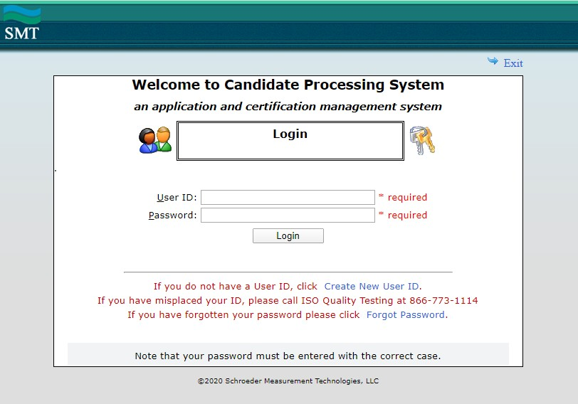
TESTING AGENCY
Prometric assists the AHVAP in the development, administration, scoring and analysis of the Certified Value Analysis Healthcare Professional (CVAHP) examination. Prometric has more than 70 years of experience providing worldwide testing solutions to corporations, federal and state government agencies, professional associations, certifying bodies and leading academic institutions.

NONDISCRIMINATION POLICY
Prometric does not discriminate among candidates on the basis of age, gender, race, color, religion, national origin, disability, marital status or any other protected characteristic.

COMPLETING YOUR APPLICATION

1. Access the Candidate Processing System using the link provided on the AHVAP website within the Certification menu.
2. On the Welcome page, click the Create New User ID record.

Select the Create New

User ID option.

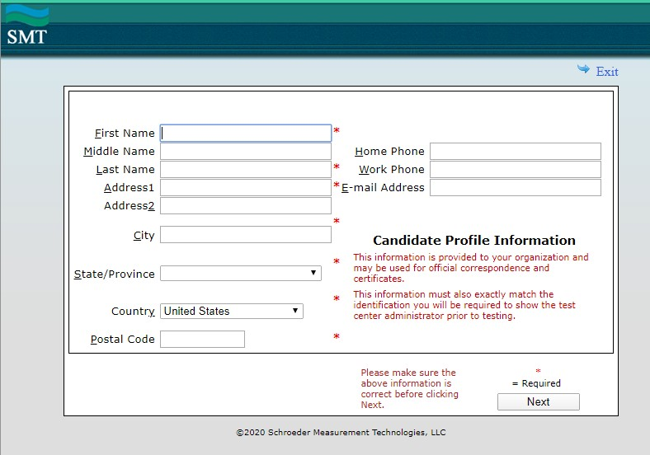3. As a new user, fill in the profile information.

It is imperative that you verify and correct the information on this page. If you need to change your name or email address, you should do so by contacting AHVAP at
info@AHVAP.org

Once you have entered all the requested information, click the
Next button.

4. Once you have entered your profile information and clicked on the next button you will receive your IQT User ID and Password. You must register your name exactly as it appears on your government issued ID. Please keep your User ID and Password somewhere safe, as you will need this to schedule your exam, update your
Continuing Education credits and renew your certification.

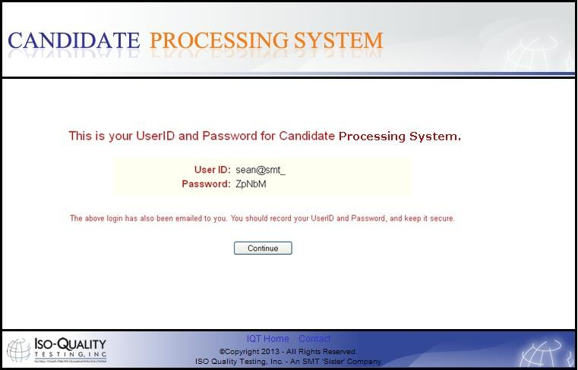Once you have recorded your User ID and Password, click the Continue button.
5. Enter your User ID and Password in designated spaces of Login page.

Enter your User ID and Passcode in the designated spaces, and
click the Log-In button.

REGISTERING FOR AN EXAMINATION

Step 1. Once approved to sit for an exam, the candidate will receive the following email from registrations@isoqualitytesting.com. The candidate will use this email to schedule their exam.

Friday, July 17, 2020
Dear Candidate,

You have now been approved by AHVAP to schedule an appointment to sit for your examination. Please proceed as follows:

1 -- Go to our home page: www.IQTTesting.com
2 -- Using the option "Exam Registration"
3 -- Select the Organization: Association of Healthcare Value Analysis Professionals.
4 -- Select the exam: Certified Value Analysis Healthcare Professional Exam.

5 -- Enter your Username and Password to log in. These are:

Username: ------------@------.---
Password: ********

After logging into the IQT website, please follow the on-screen instructions for scheduling an appointment. Please note that you must test within a 90-day date range.

Reschedule/Cancellation Policy: If you fail to show up for your examination at the scheduled time, do not have the proper identification, or do not have your admission document, you will not be allowed to sit for your exam. You will be considered a 'No-Show', your examination fees will be forfeited, and you will be required to re-register and pay all fees prior to sitting for the exam. However, if an issue arises that prohibits you from making it to your scheduled exam, you may reschedule prior to (5) calendar days before your scheduled exam date. You may be required to pay a rescheduling fee to process
your request. If it is less than (5) calendar days, you will not be allowed to cancel or reschedule your exam unless one of the following 4 situations have occurred:

Death in the immediate family
Military Deployment
Sickness
Jury Duty

If you experience any of the above issues, you MUST provide IQT with proper documentation before being rescheduled to a new date. If none of the above are the reason for wanting to reschedule or cancel your exam less than 5 days prior to your exam date, then you will not be allowed to reschedule or cancel your exam. Please also note that if you do not show up, you will be considered a 'No-Show', your examination fees will be forfeited, and you will be required to re-register and pay all fees prior to sitting for the exam.

Result Letter: Please note that you MUST receive a status letter after completing the exam. Please do not leave the testing center until this has been given to you by the Proctor.

Should you require assistance, please click on the "Contact Us" button on the home page to send a message to customer service, or you may call (toll-free in USA and Canada) 1-866-773-1114, or (other countries) +1 727-733-1110.
Sincerely,
Iso-Quality Testing, Inc.
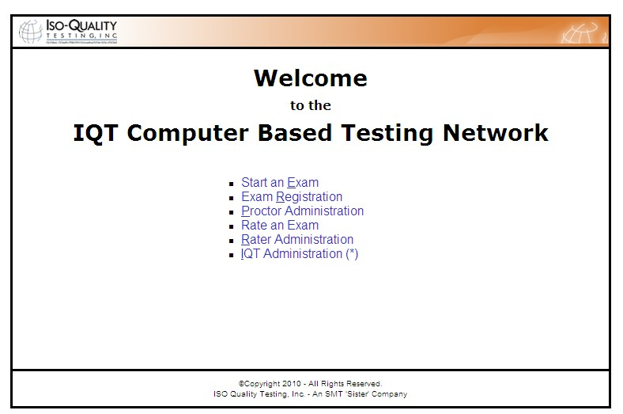Step 2. Once a candidate has received the above email, the candidate will be directed to the IQT
website, www.iqttesting.com, to complete their registration.

Once a candidate has made it to the
IQT website, they will select the second option: Exam Registration.

Step 3. From the IQT welcome screen, candidates will select from the drop down list Organization: Association of Healthcare Value Analysis Professionals and Exam: Certified Value Analysis Healthcare Professional Exam they have been pre-registered for. This information can be found in the pre-
registration email they received earlier (Step 1).
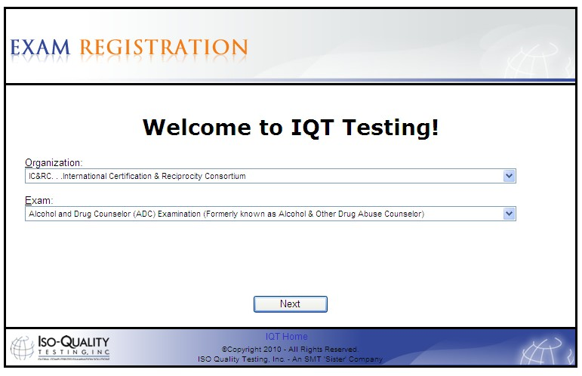

In the first drop down, candidates will select AHVAP, Association of Healthcare Value Analysis
Professionals.

In the second drop down, candidates will select the Certified Value Analysis Healthcare Professional exam they have been pre-
registered for.

Once both drop downs have been selected,
candidates will click Next.

Step 4. Candidates will then be directed to the Login screen. It is important to note that a candidate
will not be able to log in unless they have been pre-registered for an exam by the AHVAP office.
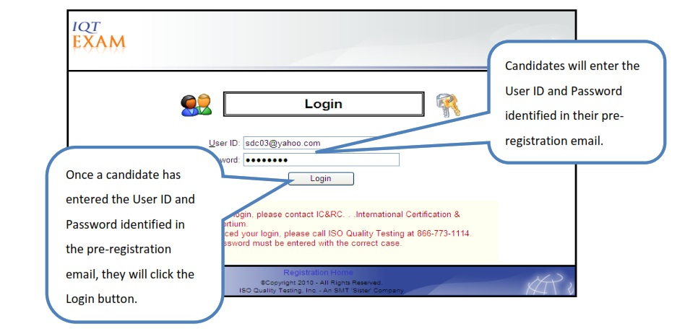

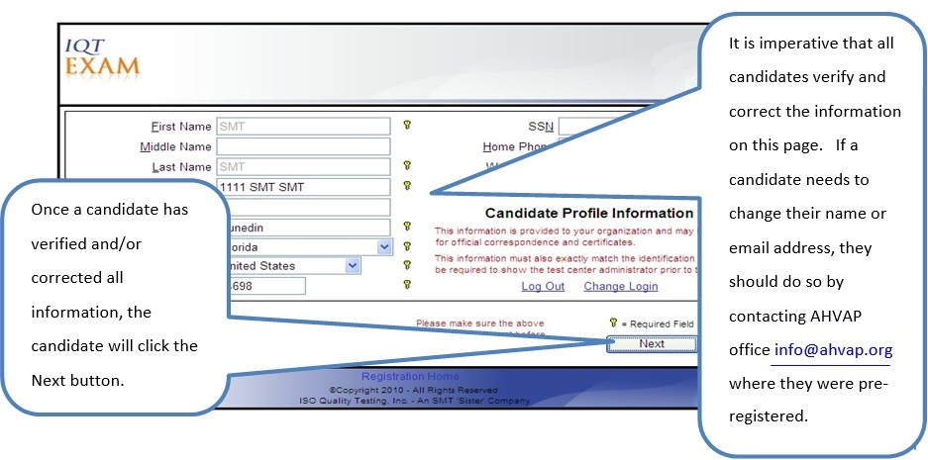
Step 5. Candidates will then be directed to the Candidate Profile screen. It is important that candidates verify all information on this page, as this information is used to populate the Admission Document and status letter. Security procedures do not allow candidates to change their name or email address. This ensures that the candidate who was pre-registered for an exam is the candidate who sits for the exam.

Step 6. Candidates will then be directed to the Site Scheduling screen. The candidate will choose the location, date, and time of their exam. This is a real-time scheduling system, so once a candidate has selected a location, date, and time for their exam and clicks the Next button, they are immediately confirmed for that location, date, and time.

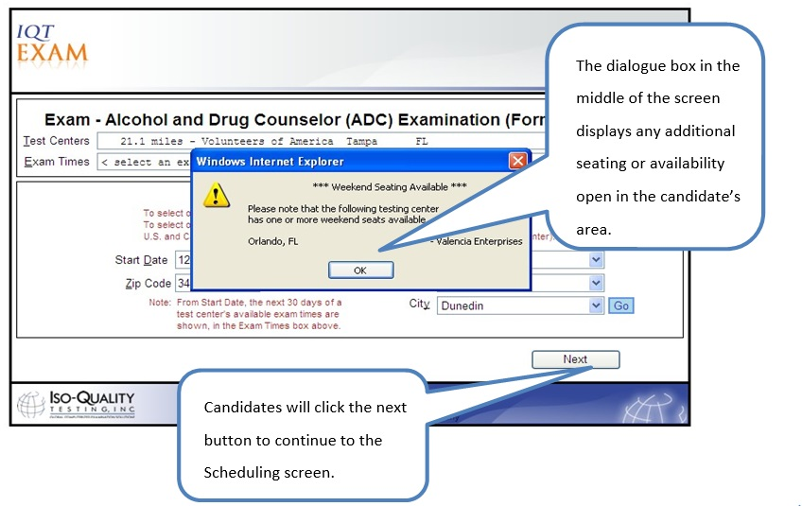

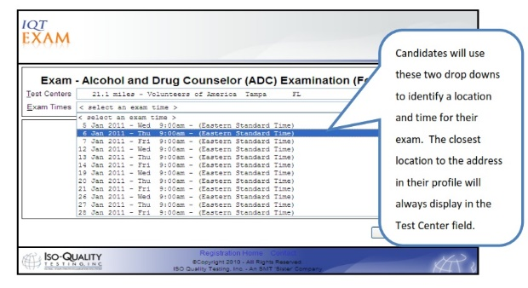
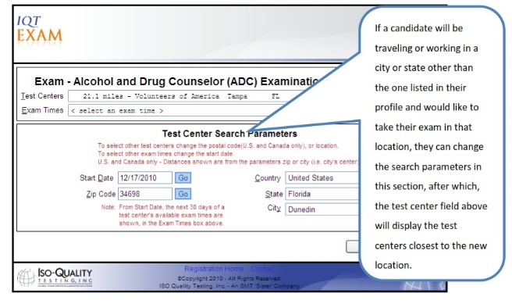

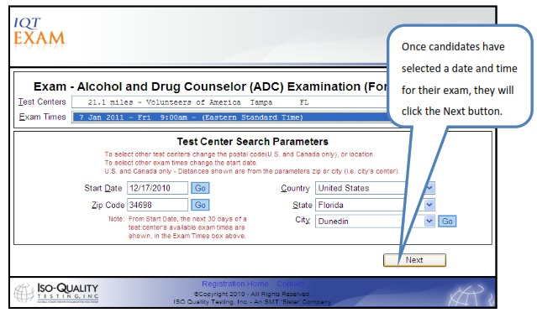

Step 7. Once a candidate has selected the location, date, and time of their exam and clicked the Next button, they will be directed to the Confirmation screen. The candidate must agree to the IQT Examination agreement prior to confirming their exam scheduling choice. Once a candidate clicks the Submit button, their scheduled exam is confirmed and cannot be changed without contacting the AHVAP office where they submitted their application.
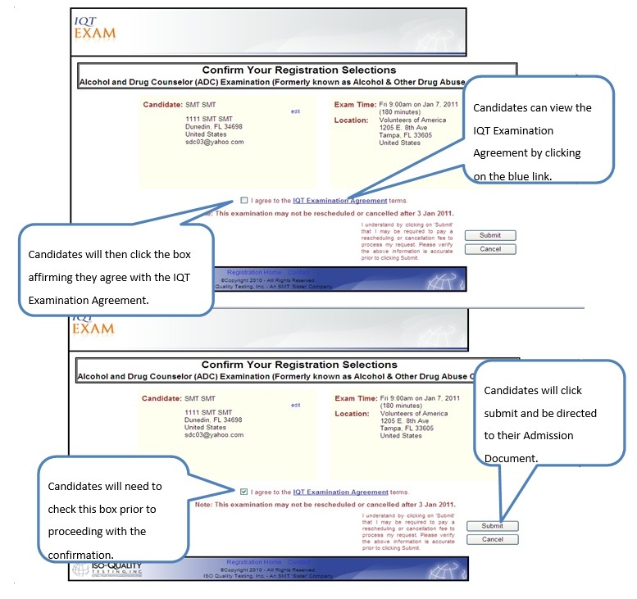

Step 8. Once a candidate has clicked the Submit button on the Confirmation screen, they will be presented with their Receipt and Admission Document. The candidate will be immediately prompted to print this document as they will not be permitted entry to the testing center without this document and one form of ID. The ID must be a valid government issued photo ID with signature. If the candidate loses or misplaces the Admission Document, they may log back into their account and print this document as many times as they deem necessary.

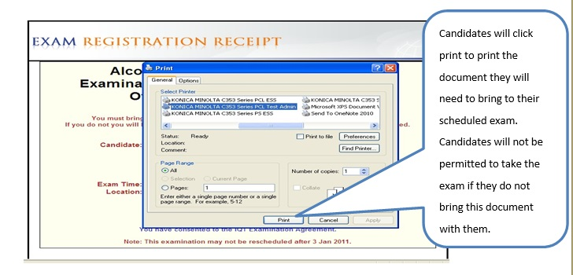 This completes the scheduling process. Candidates should read the Admission Document, as it contains all pertinent information relating to their scheduled exam.

APPLICATION AND TESTING FEE

• Member $270
• Non-Member $370
• Payment may be made by credit card (VISA, MasterCard or American Express). Examination registration fees are not refundable or transferrable and expire in one year.
• Credit card transactions that are declined will be subject to a $25 handling fee. A certified check or money order for the amount due, including the handling fee, must be sent to Prometric to cover declined credit card transactions.
• If an applicant does not appear for the test, all fees are forfeited; the applicant must resubmit a new, complete application and full examination fee.

In the event you are found ineligible to test, $100 of the fee is non-refundable to cover costs of processing.

APPEALS
Requests for exceptions to Requirements and Fees will be submitted to an AHVAP Board-appointed, three- member panel for review and recommended action.

EXAMINATION ADMINISTRATION
Examinations are delivered by computer at approximately 672 Prometric Test Centers located throughout the United States and Canada. Computer examinations are administered by appointment only. Available dates will be indicated when scheduling your examination. Appointment starting times may vary by location. Candidates are scheduled on a first-come, first-served basis.

TEST CENTER LOCATIONS

Prometric Test Centers have been selected to provide accessibility to the most candidates in all states and major metropolitan areas. A current listing of Prometric Test Centers, including addresses and driving directions, may be viewed at www.isoqualitytesting.com. Specific address information will be provided when you schedule an examination appointment. Virtual, proctored computer-based testing is also available.

SPECIAL ARRANGEMENTS FOR CANDIDATES WITH DISABILITIES

Prometric complies with the Americans with Disabilities Act and strives to ensure that no individual with a disability as defined by the ADA as a person who has a physical or mental impairment that substantially limits one or more major life activities, a person who has a history or record of such an impairment, or a person who is perceived by others as having such an impairment is deprived of the opportunity to take the examination solely by reason of that disability.

Prometric will provide reasonable accommodations for candidates with disabilities. Candidates must request special accommodations when completing their application. A Prometric Accommodations Specialist will reach out to the candidate to assist with scheduling their exam.

• Wheelchair access is available at all established Test Centers. Candidates must advise Prometric at the time of scheduling that wheelchair access is necessary.
• Candidates with visual, sensory, physical or learning disabilities that would prevent them from taking the examination under standard conditions may request special accommodations and arrangements.

Verification of the disability and a statement of the specific type of assistance needed must be made in writing to Prometric at least 45 calendar days prior to your desired examination. Prometric will review the submitted forms and will contact you regarding the decision for accommodations.

RESCHEDULING AN EXAMINATION

If an issue arises that prohibits you from making it to your scheduled exam, you may reschedule prior to (5) calendar days before your scheduled exam date. You may be required to pay a rescheduling fee to process your request. If it is less than (5) calendar days, you will not be allowed to cancel or reschedule your exam unless one of the following 4 situations have occurred:

Death in the immediate family
Military Deployment
Sickness
Jury Duty

If you experience any of the above issues, you MUST provide IQT with proper documentation before being rescheduled to a new date. If none of the above are the reason for wanting to reschedule or cancel your exam less than 5 days prior to your exam date, then you will not be allowed to reschedule or cancel your exam. Please also note that if you do not show up, you will be considered a 'No-Show', your examination fees will be forfeited, and you will be required to re-register and pay all fees prior to sitting for the exam. There is no waiting period to re-schedule.

MISSED APPOINTMENTS AND FORFEITURES

You will forfeit your examination registration and all fees paid to take the examination under the following circumstances. You will need to login into the Prometric Scheduling System, schedule a new exam date, pay the exam fee, and print your new admission document.

• You wish to reschedule an examination but fail to contact Prometric at least five business days prior to the scheduled testing session.
• You wish to reschedule a second time.
• You appear more than 15 minutes late for an examination.
• You fail to report for an examination appointment.

INCLEMENT WEATHER, POWER FAILURE OR EMERGENCY

In the event of inclement weather or unforeseen emergencies on the day of an examination, Prometric will determine whether circumstances warrant the cancellation, and subsequent rescheduling, of an examination. The examination will usually not be rescheduled if the Test Center personnel are able to open the Test Center.

You may contact Prometric, 866-773-1114, prior to the examination to determine if Prometric has been advised that any Test Centers are closed. Every attempt is made to administer the examination as scheduled; however, should an examination be canceled at a Test Center, all scheduled candidates will receive notification following the examination regarding rescheduling or reapplication procedures.

If power to a Test Center is temporarily interrupted during an administration, your examination will be restarted. The responses provided up to the point of interruption will be intact, and you will be able to continue right where you left off.

TAKING THE EXAMINATION
Your examination will be given via computer at a Prometric Test Center. You do not need any computer experience or typing skills to take the computer examination. On the day of your examination appointment, report to the Test Center 15 minutes prior to your scheduled testing time. If you arrive more than 15 minutes after the scheduled testing time, you may not be admitted.

IDENTIFICATION

• To gain admission to the Test Center, you must present your admission letter and one form of identification. The form must be government issued, current and include your name, signature and photograph. No form of temporary identification will be accepted. You will also be required to sign a roster for verification of identity.
• Examples of acceptable identifications include driver’s license with photograph; state identification card with photograph; passport; military identification card with photograph.
• The name on the Identification must match the name on the Admission Letter.
• Failure to provide appropriate identification at the time of the examination is considered a missed appointment. There will be no refund of examination fees.

SECURITY

Prometric administration and security standards are designed to ensure all candidates are provided the same opportunity to demonstrate their abilities. The Test Center is continuously monitored by audio and video surveillance equipment for security purposes.

The following security procedures apply during the examination:

- Examinations are proprietary. No cameras, notes, tape recorders, pagers or cellular/smart phones are allowed in the testing room. Possession of a cellular/smart phone or other electronic devices is strictly prohibited and will result in dismissal from the examination.
- Only silent, non-programmable calculators without alpha keys or printing capabilities are allowed in the testing room.
- No guests, visitors or family members are allowed in the testing room or reception areas.
- Candidates may be subjected to a metal detection scan upon entering the examination room.

PERSONAL BELONGINGS

No personal items, valuables or weapons should be brought to the Test Center. Only wallets, keys and non- programmable calculators are permitted. Large coats and jackets must be left outside the testing room. You will be provided a soft locker to store your wallet and/or keys with you in the testing room. The proctor will lock the soft locker prior to you entering the testing room. You will not have access to these items until after the examination is completed. Please note the following items will not be allowed in the testing room except securely locked in the soft locker.

• Watches
• Hats
• Wallets
• Keys
• Cell Phones

Once you have placed your personal belongings into the soft locker, you will be asked to pull out your pockets to ensure they are empty. If you bring personal items that will not fit in the soft locker, you will not be able to test. The site will not store or be responsible for your personal belongings.

If any personal items are observed or heard (e.g., cellular/smart phones, alarms) in the testing room after the examination is started, you will be dismissed, and the administration will be forfeited.

EXAMINATION RESTRICTIONS

• Pencils will be provided during check-in.
• You will be provided with one piece of scratch paper at a time to use during the examination, unless noted on the sign-in roster for a particular candidate. You must return the scratch paper to the proctor at the completion of testing or you will not receive your score report.
• No documents or notes of any kind may be removed from the Test Center.
• No questions concerning the content of the examination may be asked during the examination.
• Eating, drinking or smoking is not permitted in the Test Center.
• You may take a break whenever you wish, but you will not be allowed additional time to make up for time lost during breaks.

MISCONDUCT

If you engage in any of the following conduct during the examination you may be dismissed, your scores will not be reported and examination fees will not be refunded. Examples of misconduct are when you:

• Create a disturbance, are abusive or otherwise uncooperative;
• Display and/or use electronic communications devices such as pagers, cellular/smart phones;
• Talk or participate in conversation with other examination candidates;
• Give or receive help or are suspected of doing so;
• Leave the Test Center during the administration;
• Attempt to record examination questions or make notes;
• Attempt to take the examination for someone else;
• Are observed with personal belongings, or
• Are observed with unauthorized notes, books or other aids not listed on the roster.

COPYRIGHTED EXAMINATION QUESTIONS

All examination questions are copyrighted. It is forbidden under federal copyright law to copy, reproduce, record, distribute or display these examination questions by any means, in whole or in part. Doing so may subject you to severe civil and criminal penalties.

COMPUTER LOGIN

After your identification has been confirmed, you will be directed to a testing station. You will be instructed on-screen to enter your unique User ID and Passcode.

PRACTICE EXAMINATION

Prior to attempting the examination, you will be given the opportunity to get familiar with the exam software by taking the Demo Exam on the computer.

Prior to starting the certification exam at the test center, you will have access to an exam tutorial that will highlight the system features and functionality. The time you use for the tutorial is NOT counted as part of your examination time or score.

When you are comfortable with the computer testing process, you may quit the tutorial session and begin the timed examination.
TIMED EXAMINATION

Following the tutorial, you will begin the timed examination. There are 110 items (100 scored and 10 pre-test)
on the examination. You will have two (2) hours to complete the examination.

The computer monitors the time you spend in the examination. The examination will terminate if you exceed the time allowed. The Time feature may be turned off during the examination.

Only one examination question is presented at a time. Choices of answers to the examination question are identified as A, B, C or D. You must indicate your choice by either typing in the letter in the response box in the lower left portion of the computer screen or clicking on the option using the mouse. To change your answer, enter a different option by typing in the letter in the response box or by clicking on the option using the mouse. You may change your answer as many times as you wish during the examination time limit.

To move to the next question, click on the forward button or arrow (>) in the lower right portion of the screen. This action will move you forward through the examination question by question. If you wish to review any question(s), you can select the specific question in the navigation grid or click the backward arrow (<) or use the left arrow key to move backward through the examination.

An examination question may be left unanswered for return later in the examination session. Questions may also be bookmarked for later review by clicking in the yellow square under the navigation grid.

CANDIDATE COMMENTS

During the examination, you may make comments on any question by clicking on the Comment on the Question button under the navigation grid. This opens a dialogue box where comments may be entered. Comments will be reviewed, but individual responses will not be provided.

FOLLOWING THE EXAMINATION

After completing the examination, you are asked to answer a short evaluation of your examination experience. Then, you are instructed to report to the examination proctor to receive an examination completion report.

HOW SCORES ARE DETERMINED
The minimum score required to pass the examination is determined by a process known as the Angoff method, in which subject-matter experts estimate the difficulty of each item on the examination. Estimations are averaged to determine the minimum passing score, which represents the amount of knowledge a Certified Value Analysis Healthcare Professional would likely demonstrate on the examination.

IF YOU PASS THE EXAMINATION

Candidates who are successful in passing the examination will receive a congratulatory packet and a certificate suitable for framing from AHVAP approximately four to six weeks after the examination.

IF YOU FAIL THE EXAMINATION

Candidates who are unsuccessful in passing the examination will be automatically pre-registered to retake the examination. There is no limitation to the number of times a candidate may test for certification, and there is a 30-day-wait period between retakes. Once you receive your new preregistration email, please visit www.iqttesting.com to schedule your exam. You will be required to pay a new examination fee.

SCORE CANCELLATION

Prometric is responsible for the validity and integrity of the scores they report. On occasion, occurrences, such as computer malfunction or misconduct by a candidate, may cause a score to be suspect. Prometric reserves the right to void or withhold examination results if, upon investigation, violation of its regulations is discovered.

FAILING TO REPORT FOR AN EXAMINATION

If you fail to report for an examination, you will forfeit the registration and all fees paid to take the examination. A completed application form and examination fee is required to reapply for examination.

CONFIDENTIALITY

Information about candidates for testing and their examination results are considered confidential. Studies and reports concerning candidates will contain no information identifiable with any candidate, unless authorized by the candidate.
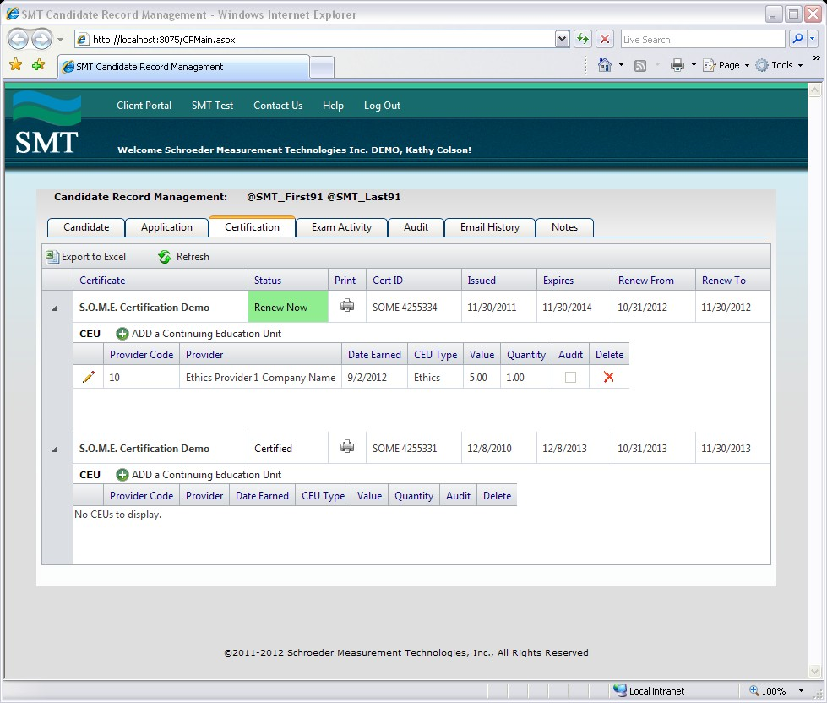
DUPLICATE SCORE REPORT
You are able to log into your certification record and reprint the result letter as you deem appropriate.

CERTIFICATION RENEWAL
• Recertification Fee
o Member $150
o Non-Member $250
• Term is 3 years
• Applicant is required to submit a record of completion of 45 hours of educational credits related to the four pillars of Healthcare Value Analysis: Governance and Structure, Healthcare Value Analysis Methodology, Professionalism and Business Ethics, and Finance. Credit hours must be logged in the SMT Candidate Processing system (smttest.com). The following information is required to log your
education: Provider type (select the type of education hours earned from the drop-down list), Provider name, Domain (select the AHVAP pillar from the drop-down list), Quantity (number of educational
hours earned for the activity), and date earned. Click on “Saved” at the top left of the screen to add the
entry. The log keeps a running tally of your credit hours.

Click the printer icon to view and print the
Certificate.

Click ADD a Continuing

Education Unit to enter in

CEU’s.
Click Renew Now to renew your Certificate.

Click Save to save changes, Cancel to
cancel changes.
Add CEU
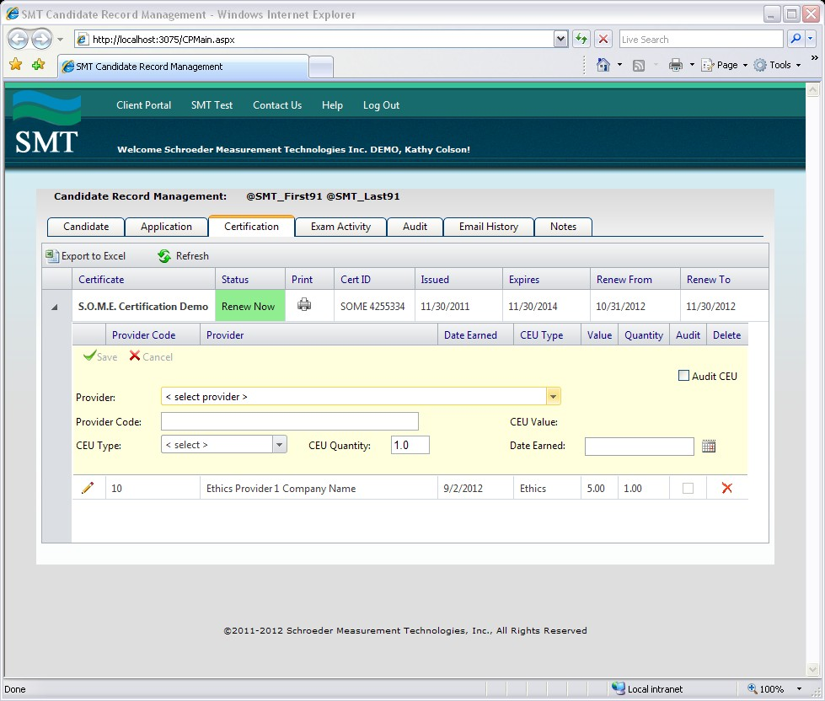

Select CEU provider from provider list, enter the quantity (occurrence, years, etc.) and
the date earned.

• Educational Credits required for renewal based on the Education Type, Maximum Credits and Proof of
Completion per the table below.

• Educational credits must be completed during the current certification renewal period. Excess credits

do not carry over to the next period.

• Proof of completion must be submitted only if you receive notice your educational entry is being audited.
• Sessions must be at least 30 minutes in duration and be reported in a minimum of 0.5 contact hour increments
• Attendees must be in attendance at least 50 minutes of a 60-minute webinar/lecture to receive credit for the session. Hours reported in excess of the maximum allowed for an Education type will not be eligible toward certification renewal requirements.

Education Activity Type | Education Description | Maximum Credits eligible to be applied per renewal period | Proof of completion required for audit
Attendance to CE  Event/program | Attendees must be in  attendance at least 50 minutes of a 60-minute or 25 minutes of a 30 minute webinar/lecture to receive credit for the session | 45 CE | Proof of attendance
Educational Program/  Professional Presentation/ Podcast | Preparation and  presentation of an educational session will recognize 10 hours of educational credit for each one-hour presentation and 5 hours for a one-half hour presentation | No more than 20  educational credits | Submit date, time,  location and title of presentation and presenter name(s)
Authoring/Publishing | Professional publication to  include state and national organization publications | 5 educational credits for  each article with maximum of 15 educational credits | an e-link to the article or  include a copy of the article.
Academic Coursework | From an accredited college  or university  • One (1) semester credit  = 15 contact hours  • One (1) quarter credit =  10 contact hours  Includes in-person and online | 15 contact Hours | Grade report or  copy of transcript
Self-study program | Program provided by a  professional healthcare Association. Provider must award contact hours  • Includes audio conferences and online education | Maximum 9 contact hours | Certificate of completion  with contact hours earned
Poster Presentation  (national meeting) | Subject: value analysis | Maximum 6 contact hours  3 different posters  2 contact hours each | Electronic copy of poster
Blog or other Social Media  contributions | Research and evidence-  based information related to value analysis. Opinion pieces | Contact  info@AHVAP.org to discuss | e-link to posting
EDUCATIONAL CREDITS QUICK REFERENCE
REINSTATEMENT OF AN EXPIRED CERTIFICATION
When certification is not renewed by the expiration date, certification may be reinstated up to 12 months following the expiration date by:
- Sending a request for CVAHP Reinstatement to info@ahvap.org with “CVAHP Reinstatement” in the subject line. Prometric will be notified so that your SMT Candidate site can be activated to allow you access to the system.
- Submitting a record of completion of 45 hours of educational credits related to the four pillars of Healthcare Value Analysis: Governance and Structure, Healthcare Value Analysis Methodology, Professionalism and Business Ethics, and Finance.
- CE’s must be completed in the three year period preceding the date the application is submitted.
- Educational credit hours must be logged in the SMT Candidate Processing system https://www.smttest.com/candidaterecordmanagement/cplogin.aspx?cnid=311 before the renewal can be processed and may be subject to a random audit.
- The applicant must submit the renewal fee AND a $50.00 administrative fee with the request for reinstatement.
- The new 3 year certification period begins the date the application is approved.

Note: For certifications that have expired more than 12 months beyond the expiration date, certification may be reinstated by registering for and successfully completing the CVAHP Certification exam.

